|  |
| --- |
| Njay Corporations |
| Student Registration |
| V 1.0 |
|  |
| **Neeraj Kumar Singh** |
| **3/9/2015** |

|  |
| --- |
| Student Registration project is an application. Student can do their registration by accessing this site. Admin user can accept/reject application on the behalf of student’s input. |

## Table of contents

Table of contents 2

Project Management Plan 3

Requirement Specifications 5

Analysis 5

Design 5

Implementation 10

Uses 11

## Project Management Plan

The purpose of Student Registration is basically for student and college admin. By this project student can register with some initial information. Student also can track his status by login the site. Here for admin purpose we have provided special login credential with full privilege. Admin can accept/reject applicant’s application.

## Requirement Specifications

Requirement is very simple; develop an application Student Registration which should helpful for students as well as college admin.

I have mentioned below in points all requirements

1. Student and admin should access same site.
2. Student should register by accessing the site.
3. Student should enter his/her basic information’s.
4. Student should update his/her basic information’s.
5. For admin purpose should have only one login credential.
6. Admin should able to see all details of student
7. Admin should able to get **Accept/Reject** link
8. Admin should able to Reject/Accept applicant’s applications.
9. Student should able to see all students in advance table.
10. Advance table should have search box with table.
11. Student/Admin should able to logout.
12. Student should recover his forgot password.
13. Student with same email id should not able to register
14. In registration page all inputs should validate before saving the data to DB.
15. Create db/tables/store procedure through front-end.

## Analysis

I have done the analysis for above requirement. There is no issue.

## Design

I have design all pages

* **Admin page for create the DB/Tables/Store Procedures**

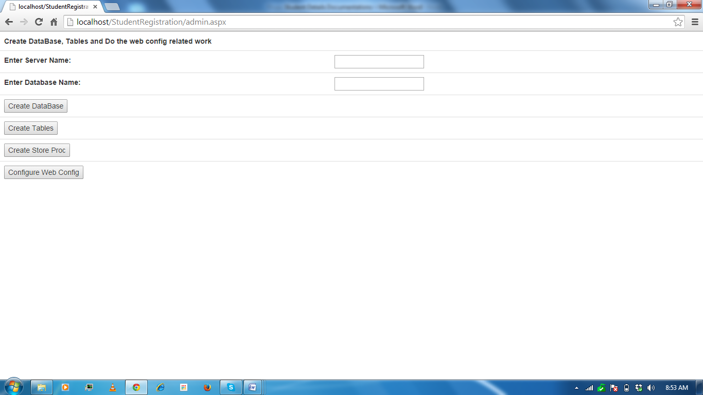

**Description:-**

1. User has to enter server name only for example my server name here **SQLEXPRESS**

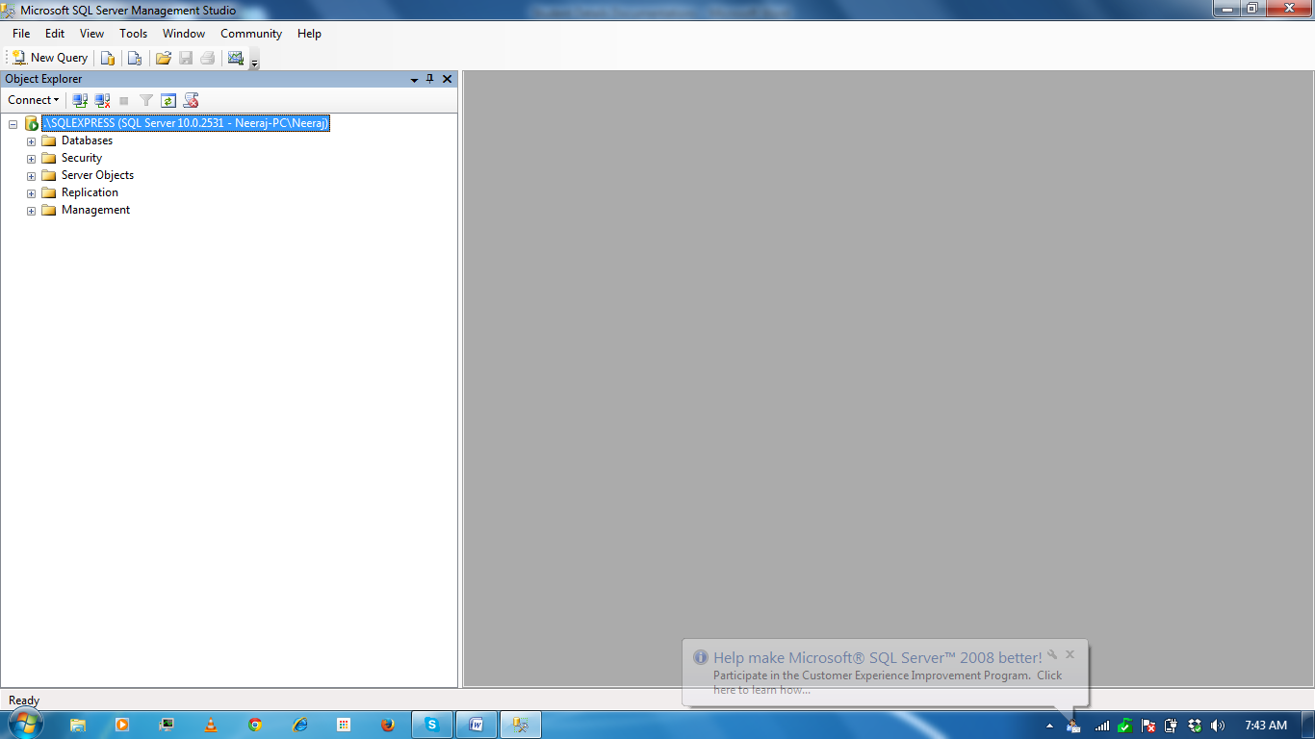

1. Then enter database name it can be anything except number
2. Click on Create data base button. And wait 10 second data base will create in SQL server
3. Click on Create tables
4. Click on store procedures
5. Click on establish connection sting

Now project is ready for use

* **Student Registration page**

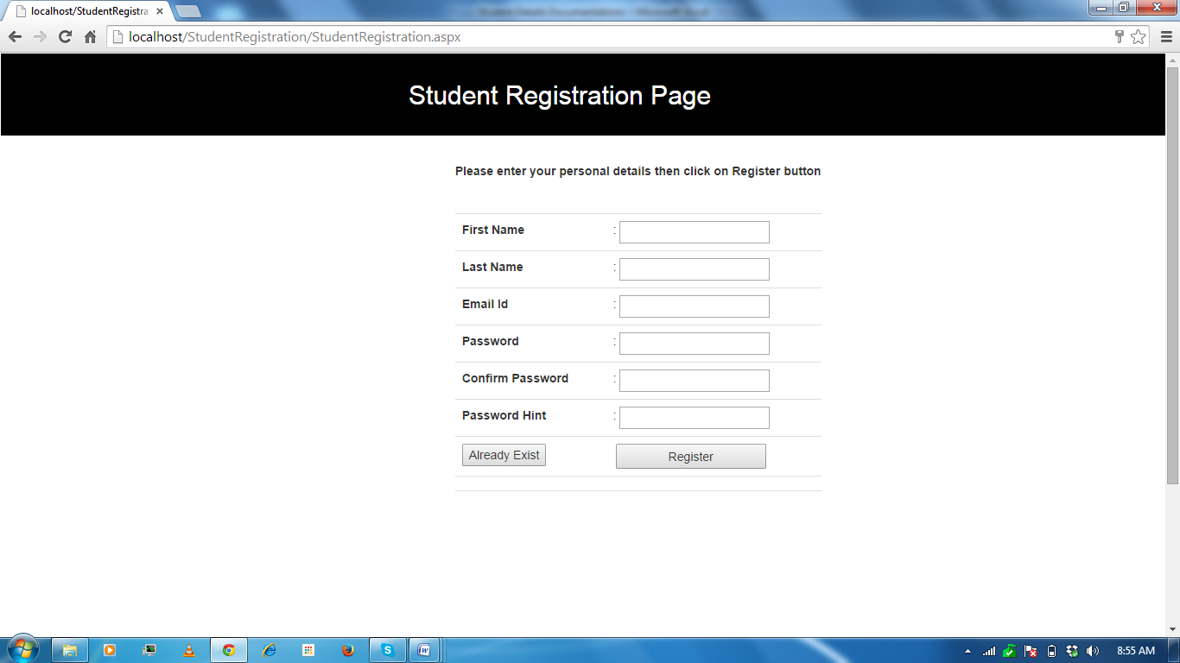

**Description:-**

1. Here for all controls input is required
2. Validation has given in server side code
3. Must enter Password hint that only help during password recovery
4. Click on register you will navigate Details.aspx page, there you can enter their more information
5. If you have already credential go click on Already Exist button, it will navigate to StudentLogin.aspx page.

* **Student Login page**

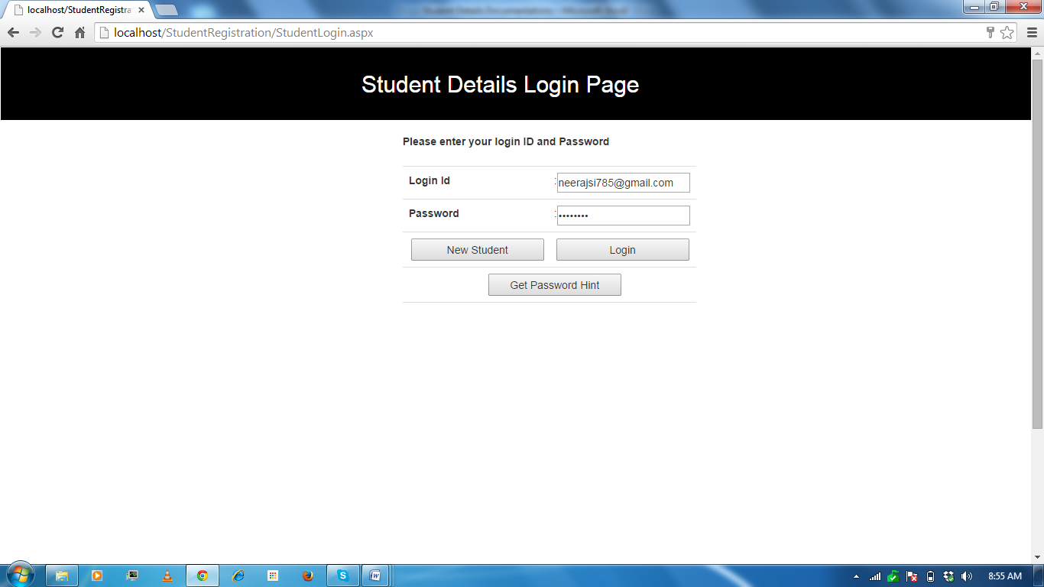

**Description:-**

1. If you don’t have credential click on new Student button for new registration
2. If you have forgotten your password , then click on Get Password Hint button
3. If have already credential, enter your Email ID and password then click on login button, it will navigate to you on Details.aspx page.

* **Student Forgot password page**

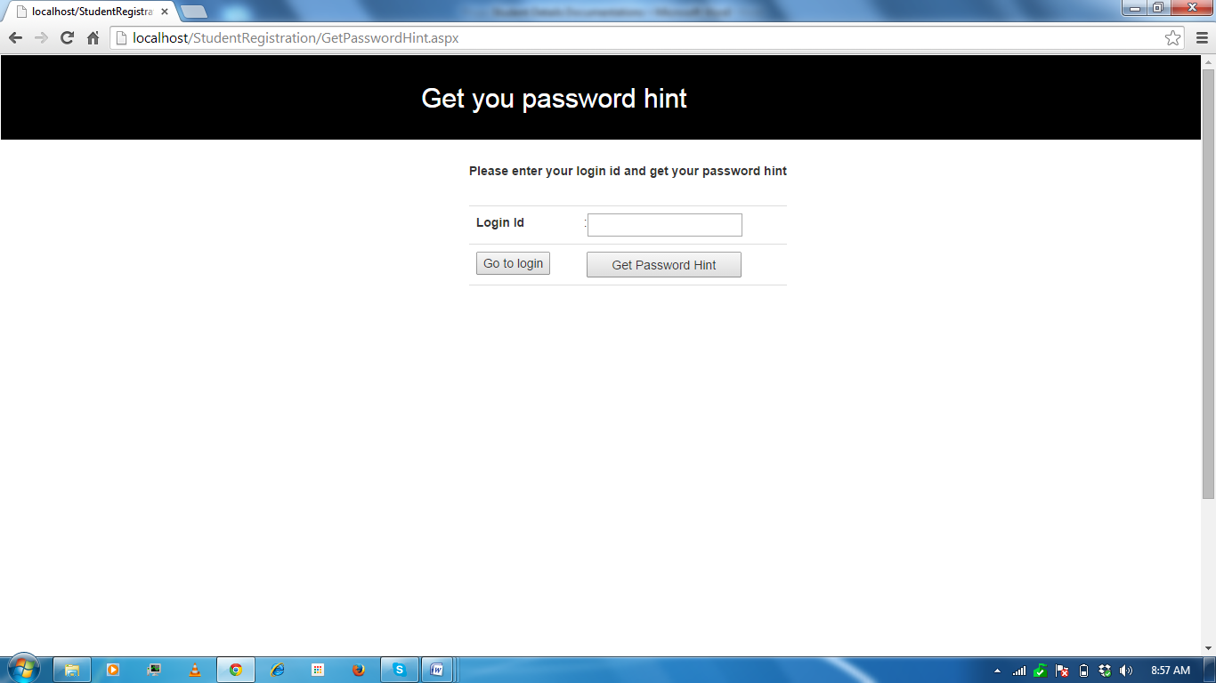

**Description:-**

1. To get the password hint enter your email id then click on Get password hint
2. After getting the password hint click on Go to login page button.

* **Student Details for Student**

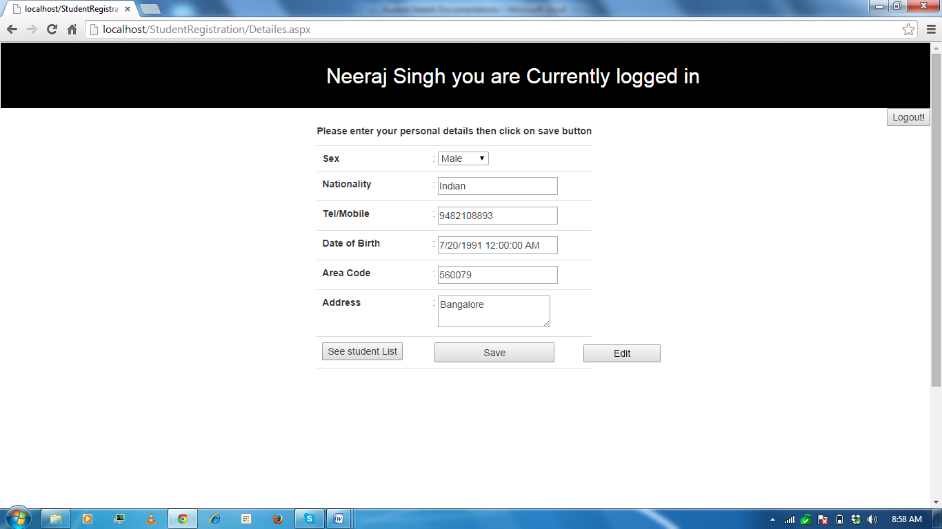

**Description:-**

1. If you are doing first time login then all input controls will be empty/ default value.
2. To edit your information click on Edit button and enter your information.
3. Date of birth please enter in right format (YYYY/MM/DD)
4. To save your information into DB click on save button.
5. To see the all student details table click on See student List button.
6. For logout click on logout button.

* **Student Table for Student**

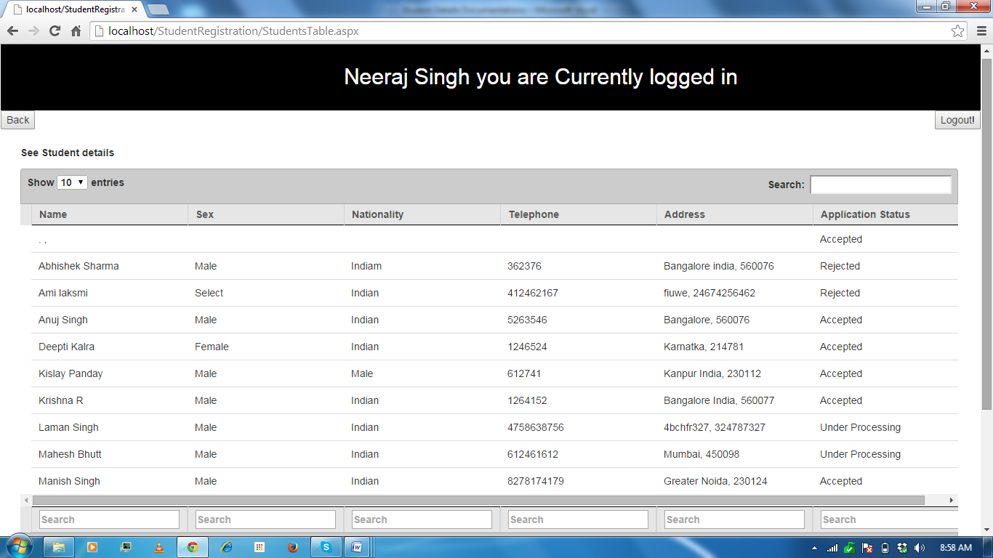

**Description:-**

1. Here user can see all students who have applied application for registration.
2. Applicant’s Application Status will tell application has been accepted/rejected/under processing.
3. User can search/filter information by columns wise footer search box or by main search box.
4. By clicking on back button logged user can go Details.aspx page.
5. User can logout from here on clicking the logout button.

* **Student Table for Admin**

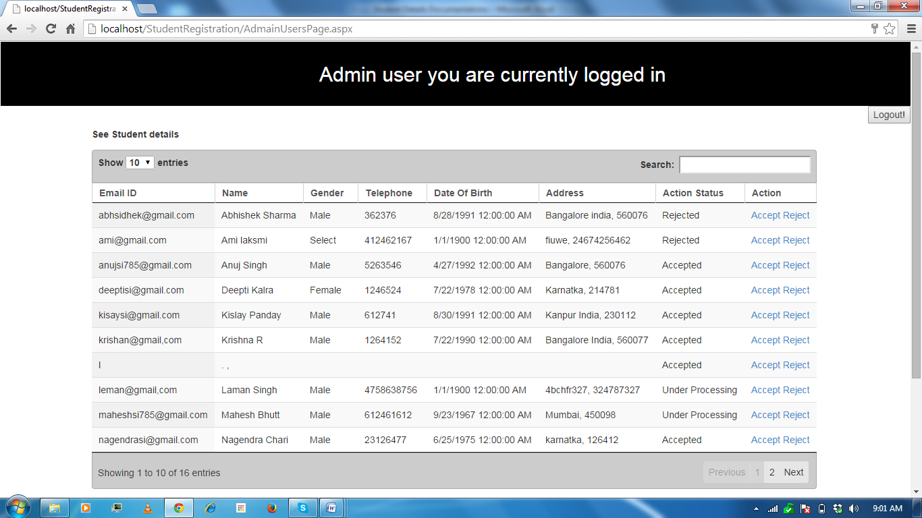

**Description:-**

1. This table only will be seen by admin.
2. For admin purpose I have created special credential (admin/admin)
3. To login the admin user has to go StudentLogin.aspx page.
4. Enter admin in EmailID and password section then click on login button, admin user will be admin table page.
5. To log out admin user from the site click on logout button.
6. Admin can accept/reject application corresponding applicant.
7. To Accept the XYZ’s application, go to XYZ’s row and click on accept link you will get alert popup, click on ok.
8. To Reject the XYZ’s application, go to XYZ’s row and click on reject link.
9. In order to see the changes of application status click on ctrl+f5, two times.

## Implementation

Here I am not going to give full description; I will give basic info of the implementation

**Used Languages/Technologies:-**

**Technology**: .Net

**Languages & Plugins:** C#, ADO.NET, ASP.NET, jQuery, AJAX, HTML, CSS, jQuery DataTable, Bootstrap, SQL, JSON.

**Server Side languages:** C#, ADO.NET

**Client side Languages and third party plugins:** ASP.NET, HTML, CSS, jQuery, AJAX, JSON, jQuery DataTable

**Data Base:** SQL server 2008

**Editor:** Visual Studio 2010

**Tested Browsers:** Google Chrome

## Uses

* Go to the <https://github.com/njay26/StudentDetails> and download the StudentDetails.zip file.
* Extract all files from StudentDetails.zip file to your local disk.
* Open project using visual studio 2010 onward
* Open StudentTable.aspx.cs file and give the right path for Data.txt file
* Open AdminUsageTable.aspx.cs file and give the right path for AdminUsage.txt file
* Run the application
* Go to the admin.aspx page in browser create DB, tables, store procedures along with connection string.
* Now use application by following above design screen shot with description

Thanks

Neeraj Kumar Singh